**IOT CONTROLLED SMART AMBULANCE**

**INTRODUCTION**

The growth of industrialization and urbanization has lead to an immense increase in the population invariably leading to rise in the number of vehicles on road. Traffic management on the road has become a biggest severe problem of today's society. There are so many examples that ambulance got strucked in the traffic load, Ambulance has to wait for some minutes to hours to clear the traffic load. Patient may die because of lack of treatment at proper time. MORE THAN 20 per cent of patients needing emergency treatment have died on their way to hospital because of delays due to traffic jams and uncooperative motorists, National Institute of Emergency Medicine (NIEM) secretary-general Anucha Setthasathian said. Santosh H.L., a paramedic, said that a lady in labour was stuck for nearly two hours on Thursday evening. “The lady was in a lot of pain. But there was not much we could do as the entire road was blocked and there was no way the vehicles could make way for us,” he said.There are many similar instances reported everywhere in India.So we come up with the idea of Smart Ambulance.

The process presently in use in case of traffic light is being shown in the figure. In traffic load everyone has to wait until they get green signal especially when ambulance has arrived it must wait to clear the vehicles on road ,this principal is based on vehicle detection, image processing vehicle detector method, So new technology i.e. combined technology of embedded system and IoT which can get the maximum benefits and saves many lives. The main aim is to resetting the timer[signal board] to green signal whenever ambulance has in path which got the traffic load and making the opposite signal board to red signal This process is controlled by the ambulance and IoT.That is ambulance driver will send the request to signal point by using GPS location and by using cloud user connecting to the cloud server by GSM technology when the request was sent to the signal board it automatically sends the received acknowledgement. Hardware implantation requires ARM processor, Display board, GPS, GSM platform hubs and software includes algorithm for IoT cloud servers and accessing points.

Our system i.e. for ambulance gives a special path in which all the red signals will be turned to green for the ambulance which helps the ambulance in reaching its destination within time. Generally the ambulances pick up the patients and take him to the hospital, after reaching the hospital, the actual treatment starts. In this so much time is wasted and the patient might lose his life. Our system continuously analyze vital health parameters of the patient like blood pressure, heart rate, body temperature in the ambulance itself and send it to the hospital’s database while reaching the hospital, so the hospital authorities will know what Type of treatment to be given to the patient, saving so much time which ensures to save patient’s life.

**PROBLEM STATEMENT: 1**The ambulances often get stuck at the traffic signals where all other vehicles try to squeeze in to all the available space so as to move ahead as soon as the signal turns green. That is, the arrival of the ambulance is to be communicated to the nearest traffic signal, so that it can turn the light to green and hence clear the traffic.**2**While transiting the patient from source to the hospital there is a lack of communication between the patient in the ambulance and doctor where no measures can be taken to hospitalize the patient with proper direction. This problem is solved in our project by sending the measured parameters like heart rate and body temperature to hospital priorly where a suitable measure can be taken.

**WORKING**

The above figure describes about the ambulance part which is placed within in the ambulance so ambulance driver can access this device through GPS driver traces the location and send the location updates to traffic control management and GPS I connected to the ARM processor and GSM module because to send the message to traffic management and also to get the acknowledgements from the receiver side and this communication should takes place with the high security and information is encrypted and this process is carried away by the internet of things and through IoT information can be sent without delaying the time. The figure below illustrates through IoT information is sent to signal logic gate by GSM module and by using Optocoupler circuit all the information is passed and control by PC and through PC controlling of Traffic Control LED takes place as shown below.

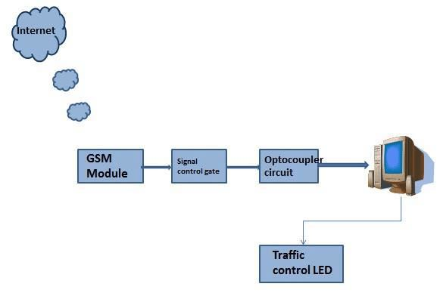

Here we send live information about the patient’s health to the desired hospital selected by the user. Using various smart devices support enabled hardware components, the readings will be recorded by the system which will be available inside the ambulance. The app will send the data in the form of live feeds so that hospital management can make necessary pre-requisites till patient reaches the hospital. It is said that treatment given while taking patient from source place till hospital is most crucial in case of any heart related problem and emergency. Thus Hospital administrative person can guide which actions should be taken until patient it reaches hospital.

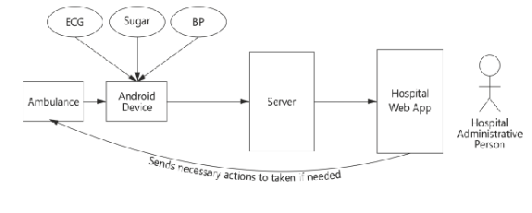

**HARDWARE IMPLEMENTATIONS :**GSM module: The GSM is a cellular network which means that cell phones connect to it by searching for the cells in the vicinity. The coverage area varies according to cells the mobile phones uses. The horizontal radius of the cell varies depending upon the height of the antenna and, gain of antenna and preoperational conditions from few hundred meters to several kilometers. 35kilkometers is the longest recorded distance for which the GSM supports. The network operates in number of different frequencies varying from few 900MHz to 1800MHz which is typically known as 2G. The transmission power is limited to a maximum of 2Win GSM 850/900 and 1W in GSM 1800/1900.

GPS: The satellite navigation system which is based on space and provides the information about the location and time irrespective of the condition of weather anywhere on or around the earth provided there is an unobstructed line of sight for at least four or more satellites. Typically the GPS provides the accurate location within few meters. The extraction of time information is also possible enabling the frequency and the timing to be maintained very accurately.

Optocouplers: This is the circuit designed for the provision of complete electrical isolation between the input and the output sources. This provides protection to the output source from high voltage, surge voltage, low level noises that produce erroneous output. The input for this circuit may be the photo transistor, LDR, photo diode etc. As and when the output of input is biased forwardly, the light is emitted from the LED, this light which is transmitted turns the photo sensitive device on and thus producing the same output voltage.

RF Transmitter: Radio transmitter and receivers are at the heart of the wireless communication. Radio stations, Television remotes, and even the door bells, radio transmitters and receivers have a variety. A small electronic device for transmitting or receiving radio signals between two or more devices. The wireless communications between two devices become a desirable characteristic when it comes to embedded systems. For this purpose we may use optical communication or RF communication. Of these two the RF is generally used because of its advantage of not requiring the line of sight. The RF modules make their usage in the fields of medium and low volume products like door openers, alarm systems, sensor applications etc. the compliance of the RF modules are defined for the communications using Zigbee, Bluetooth etc.

ARM Processor: The ARM7 (LPC2129) is a general purpose 32-bit microprocessor, which offers very high performance and low power consumption. The ARM architecture is mainly based on Reduced Instruction Set Computer (RISC) principles, and the more instruction set and it has simple related decode mechanism than those of micro-programmed Complex Instruction Set Computers (CISC). The main aim of using ARM is it has more instructions set than any other processor this simplicity results in a high instruction throughput and efficient real-time interrupt response from a small and cost-effective processor core.

**MERITS**

The growth of industrialization and urbanization has lead to an immense increase in the population invariably leading to rise in the number of vehicles on road. The resulting traffic congestion and traffic jams are the major hurdles for emergency vehicles such as ambulance carrying critical patients as these emergency vehicles are not able to reach their destination in time, resulting into a loss of human life.

Traffic jams is one of the crucial issue in India due to which ambulance services get affected on large amount, due to delay in ambulance service, patient may lose his life and number of these scenarios are getting increased day by day. ‘Green Corridor’ is the concept by which patient will get needed treatment on time. In smart ambulance different sensors like heart rate sensor, blood pressure, ECG will be judging status of vital parameters, the status of these parameters will be send to hospital’s database simultaneously traffic signals will be operated by using GPRS message through cloud. After getting status of vital parameters, hospital authorities will plan accordingly. As the smart ambulance will reach within range of 100m, signal will be turned to green if it is red, the communication between smart ambulances will be done by GPRS through cloud. Our system ensures quick response for emergency situations by automatically controlling traffic signals on the path of the ambulances.

**CONCLUSION**

Here our idea is proposed for saving a patient's life in a faster way possible. It is beneficial for users in case of emergencies as it saves time. Information about the hospitals provided helps in getting the appropriate hospital which is suitable for the patient’s treatment. The live feed data sent through the ambulance to the hospital helps in keeping track of patient's health details and reach the hospital without any time lag. Sending patient’s health information to the hospitals helps the hospital staff to get the necessary pre-requisites regarding the patient’s treatment. Hence it reduces the time complexity and helps to provide faster medical services.

As per the traffic light control system in India , whenever ambulance reached to traffic road, it has to wait for the clearance of traffic, for clearing traffic it takes a several minutes. If the case patient will not get treatment in proper time to reduce this hazard, By making use of IoT scenario, It is possible to clear the traffic by sending message to the signal board hence ambulance can reach hospital without delay in time and without wasting time for the clearance of traffic load, By making use of Embedded and IoT we can develop a model to clear the traffic while ambulance coming in the path

Future scope of this project can be planned by using some of the similar concepts used in this project. In order to save lives there are many other factors which can be taken into consideration. On the way the ambulance can get interrupted due to other vehicles. Actually blocking the way of an ambulance is a crime and the person has to be penalised. If so the ambulance captures the vehicle number and this will sent to the nearest police station.

This problem is very relevant in the current situation of our country, so the productisation of our idea will not be a hectic task. If selected for next round we will able to convince you very confidently with the help of a demo video on the working of our idea.